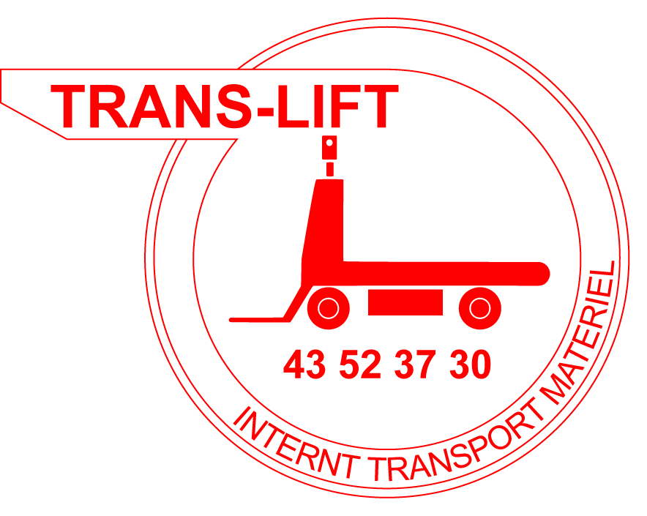
TRANS-LIFT ApS
Baldersbækvej 20-22 ⋅ DK- 2635 Ishøj
Tlf. +45 43 52 37 30
Fax +45 43 52 39 64
translift@translift.dk
www.translift.dk

USERS MANUAL
TRANS-LIFT Electric vehicle, model TL 200 AC, Cern II
Vehicle no.: TLD 1955-1956
The vehicle is meant for transportation of 1 driver and max. 300 kg cargo

Normal driving:
Turn the main switch key to "ON" position (clockwise). Situated behind the driver’s seat.
Turn ignition key on dashboard.
If necessary release emergency stop.
Choose ”normal driving” on switch on dashboard.
Choose direction - either ”forward” or ”backwards”.
Tread down dead man’s pedal.
Tread down speeder. The electric brake will be released and the vehicle will hereby begin to drive.

When you wish to make a turn – slow down your speed and turn the steering wheel in the desired direction.

Normally when braking, let go of the speederpedal.
You may also set the direction indicator in backwards position thereby using the motorbrake.

At emergency braking, tread down the mecanic brakepedal or lift your foot from the dead man’s brake.
Please note that the vehicle will then come to a sudden stop.

Please note that the vehicle will brake slowly when the speeder is not activated.
This is a regenerating function that circuit power back to the battery.
This also happens when braking with the motor brake.
When the vehicle is at a stand the electric brake will be activated (the parking brake).

Avoid that your body is outside the circumference of the vehicle during driving.
Avoid putting your feet down on the ground during driving.
Avoid driving too close to pedestrians – always slow down before dangerous situations occur.
Only use the horn in emergency situations.
Always drive with both hands on the wheel.
Ensure that the cargo can’t at any time fall off during sharp turns or when braking.

Whenever there is a low battery voltage the horn will start beeping every 10 seconds.
Drive immediately to the nearest recharging station and recharge the batteries.

When leaving the vehicle, turn main switch key to the “OFF” position (counter-clockwise).

Procedure for walking operator:

Stand next to the vehicle.
Turn the main switch key to "ON" position (clockwise). Situated behind the driver’s seat.
Turn ignition key on dashboard.
If necessary release emergency stop.
Choose ”walking operator” (mode accompagnant) on switch on dashboard.
Take the steering wheel and choose direction - either ”forward” or ”backwards” on switch either left or right on the dashboard.
The vehicle will now drive with max. 1 km/h.
Be careful while steering the vehicle.
Watch out for possible hand squeezing danger while operating the vehicle under the tube.
When you let go of the switch the vehicle will stop.

Vehicle error procedure:

Turn off the mains switch key (behind the driver’s seat). The power for the whole vehicle will be cut.
Disassemble the rear platform.
Unlock and turn the arm for the electric brake.
Hereby you deactivate the brake (any possible control current will be turned off and the vehicle can’t be driven with a deactivated brake) and the vehicle can be towed or pushed aside.
Mount the coupling in front of the vehicle and tow away the vehicle.

Charging procedure:

Turn off the main switch key (behind the driver’s seat).
Connect the mains spiralcable to the plug in the vehicle.
Connect the mains plug to a the socket.
Hereby you deactivate the control current to the vehicle.
The vehicle cannot drive with the spiral cable connected as long as there is a mains voltage in the cable.
The charging will start - see separate chargerinstruction for further information.

Ending the charging procedure:

Take the mains plug out of the socket. Take the spiral cable’s plug out of the vehicle.

SHOW CONSIDERATION DURING DRIVING
TRANS-LIFT, Ishoej, Denmark 2011

